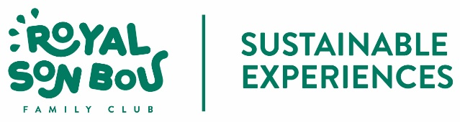

ASUNTO:  INFORME SOSTENIBILIDAD 2020 | FECHA DE EMISION  Agosto 2021 | FIRMA PARA APROBACIÓN

INTRODUCTION

At the Royal Son Bou Family Club we are committed to quality and sustainability. We consider that these are values ​​that we must unquestionably transmit to our clients and strengthen among our workers and the community.

Since 2011, our establishment holds the distinctive Travelife Gold, which means that we actively work on our commitment to protecting the environment, the welfare of our employees and the progress of our community.
With the Travelife Gold certification we show our ecological effort and our commitment to make our establishment a sustainable workplace, in which all our clients find an ideal setting for their vacations, respecting the environment, with valued workers and decent working conditions, in constant collaboration with our community.

In the latest sustainability report, corresponding to the period 2017-2019, it was explained that one of the most significant factors in the evolution was the increase in occupancy and stays. We closed the 2018 season with an occupancy of 91.01%, the year 2019 with 89.55%

The impact of the Covid19 pandemic since March 2020 has been an unprecedented event that has required a profound rethinking of all our services. The 2020 season was drastically shortened to just a couple of months of activity. Sanitary restrictions forced us to reverse some of the initiatives that had been launched in relation to the reduction of single-use plastics, bulk products, etc.
Occupancy, of course, sank to 25.88% on average in 2020.

Despite everything, our commitment to sustainability remains firm and to the extent that the situation has allowed it, we have introduced improvements and actions that allow us to develop our activity within a framework of sustainability.
PRESENTATION OF OUR BUSINESS

The Royal Son Bou started its activity in 1989.
Although in the first years of operation there was no marked specialization and our activity covered all types of customers, since 1992 the establishment begins to focus and specialize in family tourism. For this reason, the Royal Son Bou Family Club is a leading establishment on the island of Menorca, accumulating 30 years of work and experience in this sector.

The establishment has 252 apartments. This type of accommodation is included within the group Hotel-Apartment.
The 1- and 2-bedroom apartments are spread over 7 buildings surrounding the main pool. The hotel also has a children's pool (heated by solar energy), 2 restaurants and a children's area (Kikoland)
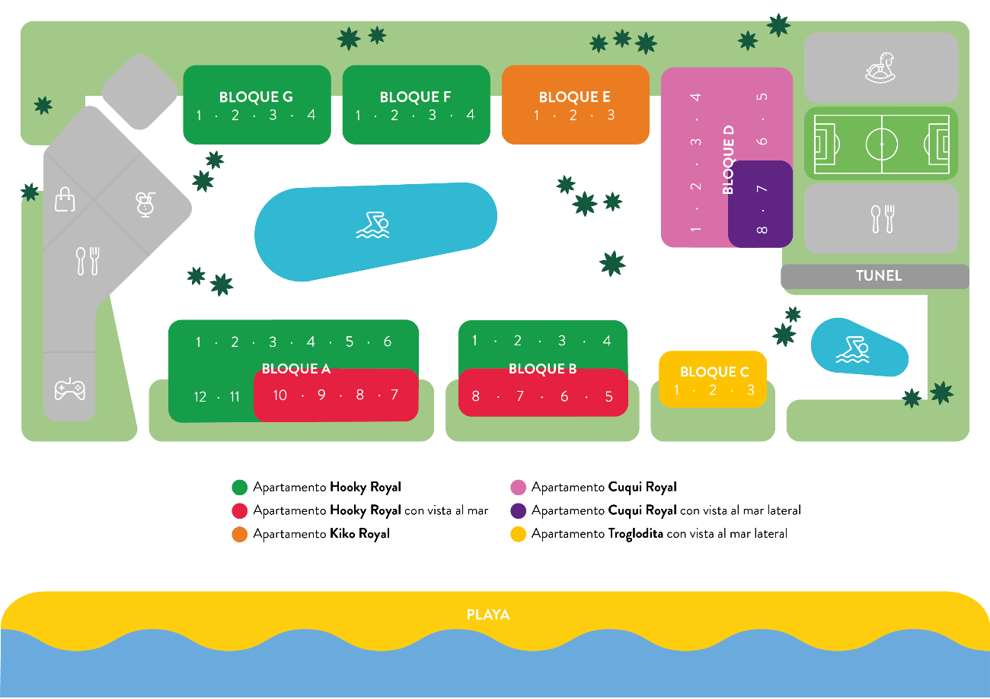

In 2014, the Consell Insular de Menorca approved the upgrade to 4 stars after satisfactorily passing the audit of its technicians.

The origin of our clients is varied, with the German, British, Swiss, Dutch, Belgian and especially during the months of July and August (high season), the Italian and Spanish customers predominating throughout the season.

DESCRIPTION OF OUR SUSTAINABILITY SYSTEM

The responsibility to implement and develop our sustainability system rests with all workers of the Royal Son Bou Family Club, from the Management to the basic personnel.

All our departments revolve around a common denominator which is service, quality and customer service. With this approach, we seek the involvement of all workers to offer quality and sustainable vacations with the environment.
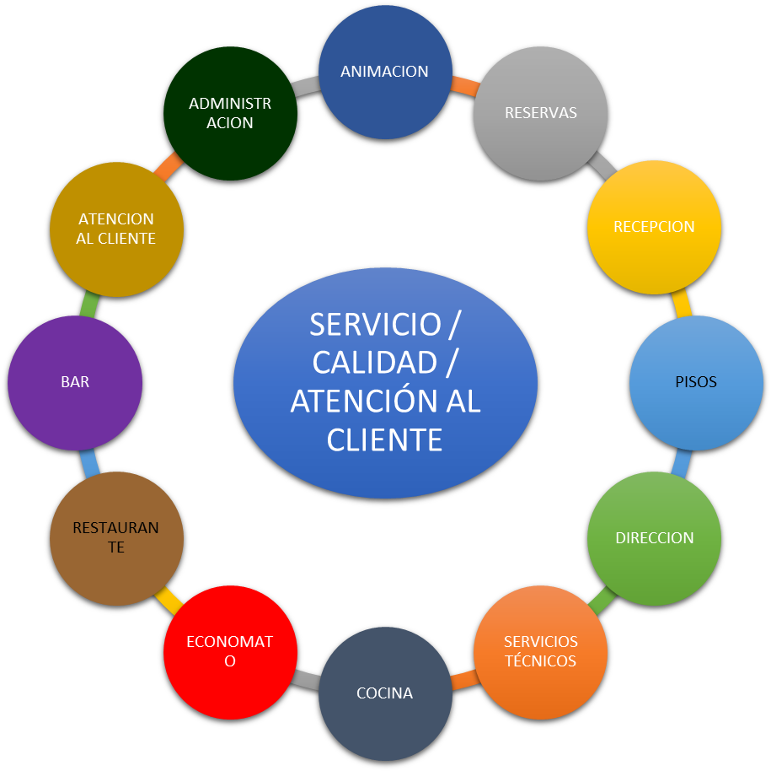

Within our team, and with the help of all the hotel staff, the person in charge of applying the requirements of our sustainability system has its representative in the figure of Arantxa González, Deputy Director of the establishment.

We actively collaborate with local companies that advise and guide us in environmental matters (Podarcis) and labor safety of our facilities and jobs, as well as the health of all our workers (Nura Prevention).

ACTIONS IN ENVIRONMENTAL AND SOCIAL MATTERS

The main lines of action since 2017 have been the following:

1.- Reduction of plastics and single-use materials.

a.- We use shampoo-gel dispensers in the bathrooms of our apartments to avoid an important volume of bottles of product.

b.- We begin to study alternatives to the plastic water bottles that are given in the all-inclusive. The possibility of installing water fountains around the pool area is being considered.

c.- Returnable polypropylene cups are purchased to avoid the consumption of single-use cardboard cups.

2.- Consumption reduction:

a.- Water flow reduction in customer apartments to minimize consumption. Installation of saving aerators in the bathrooms.

b.- Reduction of electricity consumption through the gradual replacement of halogen lighting in common areas and in the customers apartments by LED lights of lower consumption.

c.- Faucets with automatic shut-off are installed in the customer bathrooms in the common areas to avoid wasting water.

d.- Installation of heat pumps for the generation of sanitary hot water and savings in diesel consumption.

3.- Substitution of plastic materials and products by other biodegradable, recycled and / or compostable ones:
a.- Purchase of amenities (name Flow Pack) in white recycled paper packaging is confirmed. They replace the amenities that we had until now, wrapped in plastic.
b.- The napkins that we put on the tables of our restaurants are made of recycled material
4.- Awareness of our staff to achieve a bigger involvement in the tasks of recycling and waste selection. Presentation of good practices in environmental matters of each department.

Impacts minimization: good practices

Kitchen

Effective energy use

- Periodically checking for burners for correct levels of savings and efficiency
- Use pots of a size according to the cooking plates and burners to increase performance and avoid any loss of heat.
- Cover the pots during cooking and reduce the flame once the boiling temperature is reached
- Turn off the fires when there is no pan or pot heating up.
- Keep oven doors tightly closed and reduce preheating time
- Do not introduce hot food into the cold stores
- Control the temperature of the refrigerate rooms
- Defrost the internal walls of the equipment when the ice thickness is greater than 5 millimetres.
- Turn off the extractor when there is no smoke or without being used.
- Always use the dishwasher or washing equipment when fully loaded
- Control the temperature of the thermostats to optimise consumption
- Perform regular maintenance of all equipment
- Check the correct closing of the appliance doors
- Keep lights off when there is natural light

5.- Training for personnel in the field of environment and tourism sustainability.
6.- Obtained ISO14001 environmental certification in September 2019. Passed follow-up audit in 2020.

7.- Dissemination of our sustainable initiatives to our clients and community through the corporate blog. Example: Blog corporate website: How do we collaborate to maintain the environmental quality of Menorca? https://www.royalsonbou.com/es/blog/post/pasos-hacia-un-turismo-sostenible/231

8.- Increase of local suppliers / products. We bet on kilometre 0 products and local suppliers. This favors the economy of our community, reduces emissions and discloses native products to our customers.
9.- Collaboration and agreements with members of the local community that favor the economy and the activity of our environment:
a.- February 2020 (Request for collaboration from the IES Cap de Llevant for its students of Games and physical-recreational activities and tourist entertainment. Possibility of doing internships at the hotel)
10.- Continuous improvement in the working conditions of our employees:
a.- New beds with lift drive to avoid overexertion and diseases caused by ergonomic and postural deficiencies of the maids.
b.- Ergonomic training for chambermaids. In small groups, all the tasks to be carried out in the cleaning of a client's apartment are reviewed, recommendations are given to avoid postural loads.
11.- Renewal agreement with Unicef and its Hoteles Amigos project (since 2015). The funds raised will go to the WASH program: Climate Change, which seeks adequate access to drinking water and sanitation for children in impoverished areas or at high risk of flooding.
12.- Introduccion of Beca Family 2020. Included in our website in Commitments. € 3,000 Felloship for projects that attend, investigate and develop child protection initiatives.
13.- April 2019. Presentation of the preliminary draft for the construction of a photovoltaic park that supplies clean energy to the hotel.

REPORTING PERIOD

This report collects the results obtained and the actions that we have carried out during 2020.

Due to how atypical the year 2020 has been, the values, consumption, ratios and other indicators have been logically affected. It is expected that throughout 2021 this scenario can be regularized, as a longer season is planned.

The trend in the consumption of the main resources used in the establishment, electricity, water, propane and diesel is detailed below:
Our sustainability goals are as follows:

PROPANO
2.017 | kw/h | 2.018 | kw/h | 2.019 | kw/h | 2.020 | kw/h
0 | 0 | 0 | 0 | 0 | 0 | 0 | 0
0 | 0 | 0 | 0 | 0 | 0 | 0 | 0
85 | 1.100,75 | 85 | 1.100,75 | 0 | 0,00 | 0 | 0,00
1.913 | 24.773,35 | 2.159 | 27.959,05 | 1.190 | 15.410,50 | 0 | 0,00
4.828 | 62.522,60 | 5.632 | 72.934,40 | 4.879 | 63.183,05 | 0 | 0,00
5.415 | 70.124,25 | 6.163 | 79.810,85 | 5.508 | 71.328,60 | 553 | 7.161,35
5.755 | 74.527,25 | 6.316 | 81.792,20 | 6.120 | 79.254,00 | 1.998 | 25.874,10
6.217 | 80.510,15 | 6.352 | 82.258,40 | 5.959 | 77.169,05 | 2.358 | 30.536,10
5.670 | 73.426,50 | 5.840 | 75.628,00 | 5.755 | 74.527,25 | 425 | 5.503,75
2.933 | 37.982,35 | 3.196 | 41.388,20 | 3.655 | 47.332,25 | 0 | 0,00
0 | 0,00 | 0 | 0,00 | 0 | 0,00 | 0 | 0,00
0 | 0,00 | 0 | 0,00 | 0 | 0,00 | 0 | 0,00
32.816 | 424.967 | 35.743 | 462.872 | 33.066 | 428.205 | 5.334 | 69.075

GASOIL

2.017 | Kw/h | 2.018 | Kw/h | 2.019 | Kw/h | 2.020 | Kw/h
0 | 0 | 0 | 0 | 0 | 0 | 0 | 0
0 | 0 | 0 | 0 | 0 | 0 | 0 | 0
0 | 0 | 0 | 0 | 0 | 0 | 0 | 0
4.000 | 40.720 | 4.200 | 42.756 | 2.800 | 28.504 | 0 | 0
6.500 | 66.170 | 9.200 | 93.656 | 7.001 | 71.270 | 0 | 0
7.300 | 74.314 | 6.800 | 69.224 | 7.100 | 72.278 | 5.500 | 55.990
7.200 | 73.296 | 6.900 | 70.242 | 6.600 | 67.188 | 5.000 | 50.900
7.200 | 73.296 | 6.900 | 70.242 | 6.900 | 70.242 | 5.400 | 54.972
8.056 | 82.010 | 6.200 | 63.116 | 7.100 | 72.278 | 1.400 | 14.252
4.200 | 42.756 | 3.802 | 38.704 | 4.402 | 44.812 | 0 | 0
0 | 0 | 0 | 0 | 0 | 0 | 0 | 0
0 | 0 | 0 | 0 | 0 | 0 | 0 | 0
44.456 | 452.562 | 44.002 | 447.940 | 41.903 | 426.573 | 17.300 | 176.114

-From 2019 to 2021 there has been a logical reduction in water consumption, due to the pandemic situation that began in March 2020. Tons 2019 (30,530) with 133,225 stays. Tons 2020 (8,738) with 16,190 stays.

-From 2019 to 2020, a reduction in electricity, propane gas and diesel consumption has been achieved, all caused by the context of the pandemic.

-The recycling ratio per stay remained practically the same from 2017 (0.196) to 2018 (0.195). We can highlight the increase in recycled kilos of packaging in 2019 (27,626) and the usual reduction in 2020 with just 5,100 kilos for having opened both only two months of the season. The ratio per stay in 2020 is, logically, distorted by not having the same conditions as in the rest of the seasons.

 |  | 2017 | 2018 | 2019 | 2020
Envases ligeros (kilos) |  | 3122 | 7245 | 9571 | 1376
Vidrio (kilos) |  | 11160 | 9972 | 12237 | 1478
Papel (kilos) |  | 9501 | 6547,4 | 3137 | 1526
Aceite usado (litros) |  | 2425 | 2500 | 2620 | 615
Envases vacíos contaminantes (kilos) |  |  |  | 309 unidades | 32
Fluorescentes (kilos) |  | 72 | 100,4 | 19,7 | 25
Pilas (CER 20 01 33) kilos |  | 71 | 76 | 15,5
Baterías Níquel Cadmio (LER 16 06 02) |  |  |  |  | 55
Tóners (kilos) |  |  | 59 | 11 | 22
RAEES (kilos) |  |  | 31 | 15,6
Total |  | 26351 | 26530,8 | 27626,8 | 5129
Ratios por estancia |  | 0,19668889 | 0,19594532 | 0,20733214 | 0,31680049

ENVIRONMENT OBJETIVES AND SUSTAINABILITY

*We seek the minimization of waste generated by our activity, gradually replacing single-use products and / or contaminants with biodegradable, compostable and recycled products. The waste we generate is delivered to authorized managers for proper treatment.
*Renovation of machinery, lighting and equipment to achieve more efficient installations.
*Disposal of single-use plastics (all-inclusive plastic bottles).
* Get as much clean energy as possible. Photovoltaic park construction project.

OBJECTIVES IN THE LOCAL COMMUNITY

* To pursue the collaboration with educational institutions, sociocultural dynamization projects and formation of our community.
* Dissemination of our Family Grant initiative.

OBJECTIVES LABOR CONDITIONS
* Offer access to training in all matters required by current legislation. Training cycle completed to all staff in July 2019.
* Weekly meetings with the heads of department distributing in each session updated situation of our situation in different opinion and quality portals to transmit it to the base staff.
* Weekly meetings with the working group made up of base personnel from all hotel departments to study possible improvements, suggestions and complaints that they have received from clients or department colleagues.
* Ergonomic studies in all hotel departments.

QUALITY OBJECTIVES

* Renewal of the SCTE-Sicted quality certification (renewed until October 2020)
* Study for the implementation of a CRM in the hotel in 2021.

